CALL FOR PERFORMERS

Be a part of the fun at this year’s…

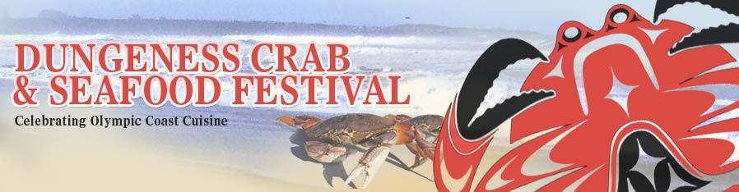

Dates: October 6 – 8, 2017
Place: Port Angeles, Washington
Wanted: Performers playing any/all musical styles

You are invited to apply to be a part of the 16th Annual Dungeness Crab & Seafood Festival!

Along with a wide variety of other activities, there will be a succession of musical performers playing on TWO STAGES (new this year!): one in the main tent (for bands) and one in the vendors/Crab Derby area on the Port Angeles City Pier (for acoustic soloists/duos/trios). Musical performances will go on throughout all three days of the Festival, starting on Friday, October 6th at 12 noon and continuing through Sunday, October 8th at 5:00pm.

If you are interested in performing a 45-minute to 2-hour set during the Festival on EITHER or BOTH stages, please and send an e-mail to Music@Crabfestival.org containing:
- your contact information (e-mail and telephone number)
- the name of the performer(s)/band
- the genre/style of music you play
- an indication of which stage(s) you’re interested in playing
- the number of performers (limit of 3 performers on the Pier stage [no drum-kits])
- the date(s) and time(s) you are available
- the preferred length of your set (minimum and maximum duration)
- a brief performer(s)/band biography (general background, festivals played, etc.)
- photo(s) of the performer(s)/band (.jpeg format)
- links to your website and
- copies of (or links to) your recordings.

ALL E-MAILS EXPRESSING INTEREST MUST CONTAIN ALL OF THESE ITEMS AND MUST BE RECEIVED BY JUNE 15th, 2017; INCOMPLETE APPLICATIONS WILL NOT BE CONSIDERED. SELECTIONS WILL BE MADE BY MID-AUGUST, 2017.

If you have any questions or need additional information, please contact Music@Crabfestival.org.

